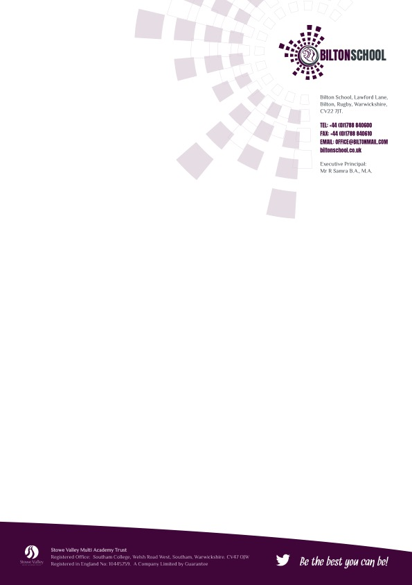

**Advice to All Parents - Single case in the school**

Dear Parents,

We have advised Public Health England that there has been a confirmed case of coronavirus (COVID-19) in school. **This is not within your child’s class/es.** This letter is to inform you of the current situation and provide advice on how to support your child.

**Please remember and reassure your child that for most people, coronavirus will be a mild illness.**

We are monitoring the situation and working closely with Public Health England, following government advice which is:

* To continue to carry out daily additional cleaning of the school
* All children identified as close contacts or in the same class have been sent home.

The school remains open and provided your child is well; they can continue to attend school as normal. We will keep this under review.

We all need to remain vigilant by watching out for symptoms of coronavirus. The symptoms are:

* a new continuous cough
* and/or high temperature
* and a loss of or change in normal sense of taste or smell

If you or your child shows these symptoms:

* **do not come to school**
* book a test immediately
* inform the school of the situation by texting: 07801 390545. We will contact you back.
* Please have the following information available to share: their method of transport to school, who they were with during social time, if they went to the canteen.
* self-isolate with your household

There are things we can all do to help reduce the risk of you and anyone you live with getting ill with coronavirus:

* wash your hands with soap and water often – do this for at least 20 seconds
* use hand sanitiser gel if soap and water are not available
* wash your hands as soon as you get home
* cover your mouth and nose with a tissue or your sleeve (not your hands) when you cough or sneeze
* put used tissues in the bin immediately and wash your hands afterwards

Further information is available at:

<https://www.nhs.uk/conditions/coronavirus-covid-19/>

Yours sincerely

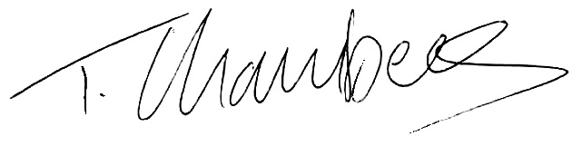

Tim Chambers

Headteacher